**PAPER – II          PRACTICAL NO. : 03**

**AIM :  1. IMPLEMENT SPAN TECHNOLOGIES (SWITCH PORT ANALYZER)**

**2. IMPLEMENT SNMP AND SYSLOG**

**3. IMPLEMENT FLEXIBLE NETFLOW**

**ROLL NO. : 02                                BATCH : M.SC PART-I**

**DATE : /11/22**

SPAN TECHNOLOGIES :

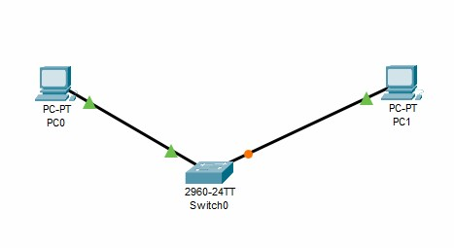

monitor session 1 source int f0/0 monitor session 1 destination int f0/2 show monitor session 1 show monitor detail

SNMP :

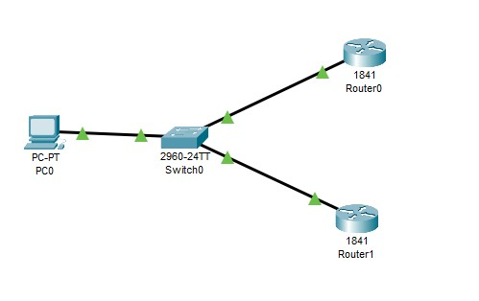

snmp-server community read ro snmp-server community write rw

Goto MIB browser and do settings

# SYSLOG :

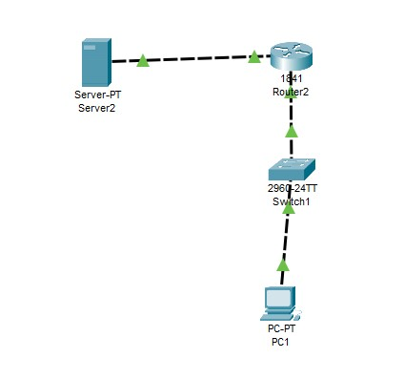

service timestamps log datetime msec int f0/0.1 check syslog of server

FLOW SIMULATOR :

int f0/0 ip flow ingress ip flow egress ip flow-export destination 10.0.0.2 99 ip flow-export source f0/0 show ip cache flow